Steps to Create a Data Visualization in Tableau Public

- Go to Tableau Public Website to start: https://public.tableau.com/app/discover
- Click: “Sign Up for Tableau Public”
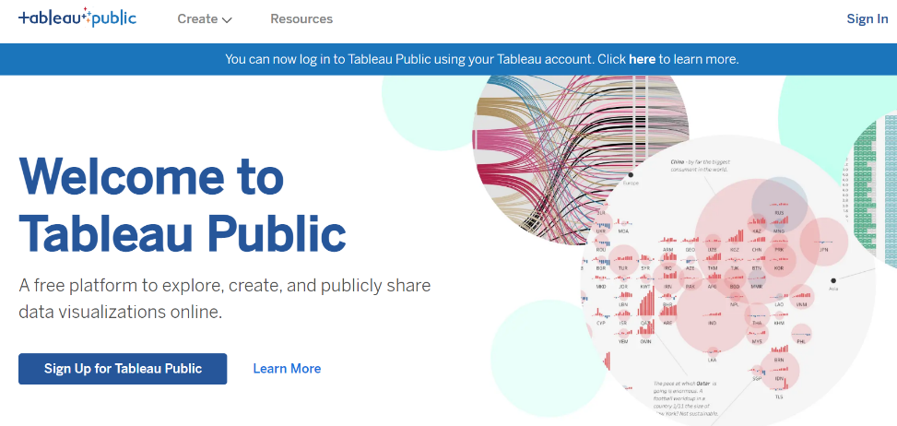

- Create your account. Be sure to pick a password you can remember.
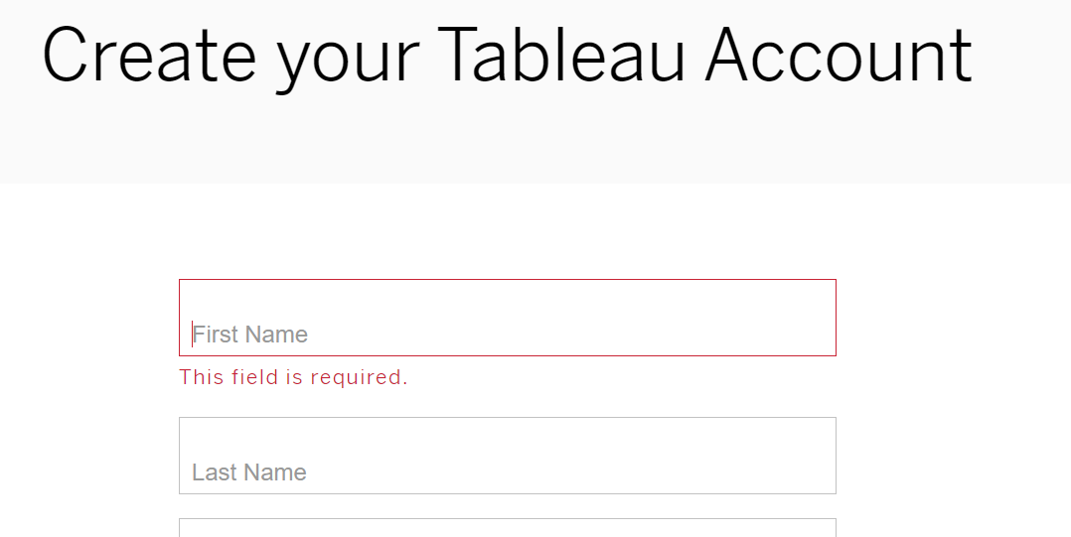

- Fill in all information; you will need to provide a personal email associated with your account, then click “create my account.”

- You will have to verify your email address, so go to your email account and verify before you continue.
- Once you are signed in, go to “Create” (top left) (website link here: https://public.tableau.com/app/discover )
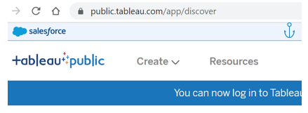

Select “Create” and then menu option ““Web Authoring”

- Sign in with the login information you provided and then click “Sign In”
- Select “United States”, agree to terms and conditions, and then click “Complete Sign In”

- Download the data set and use it to explore. For our activity, we used the penguin data set. You can download it using the instructions here: https://cran.r-project.org/web/packages/palmerpenguins/readme/README.html
You can also email me at mais.alraee@montgomerycollege.edu, and I will gladly send it to you.

- Save the Penguin dataset to “Downloads” on your computer. Then click “Upload from computer” to load the data:
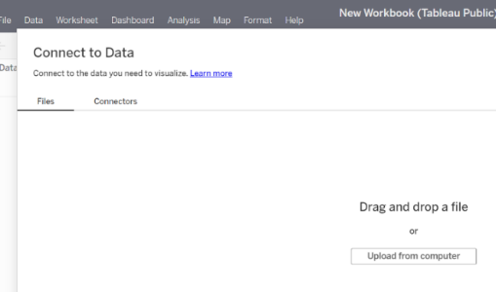

- Be patient – it takes a few seconds to load. Once it is loaded, your screen will look something like this (I am using the Penguins dataset)
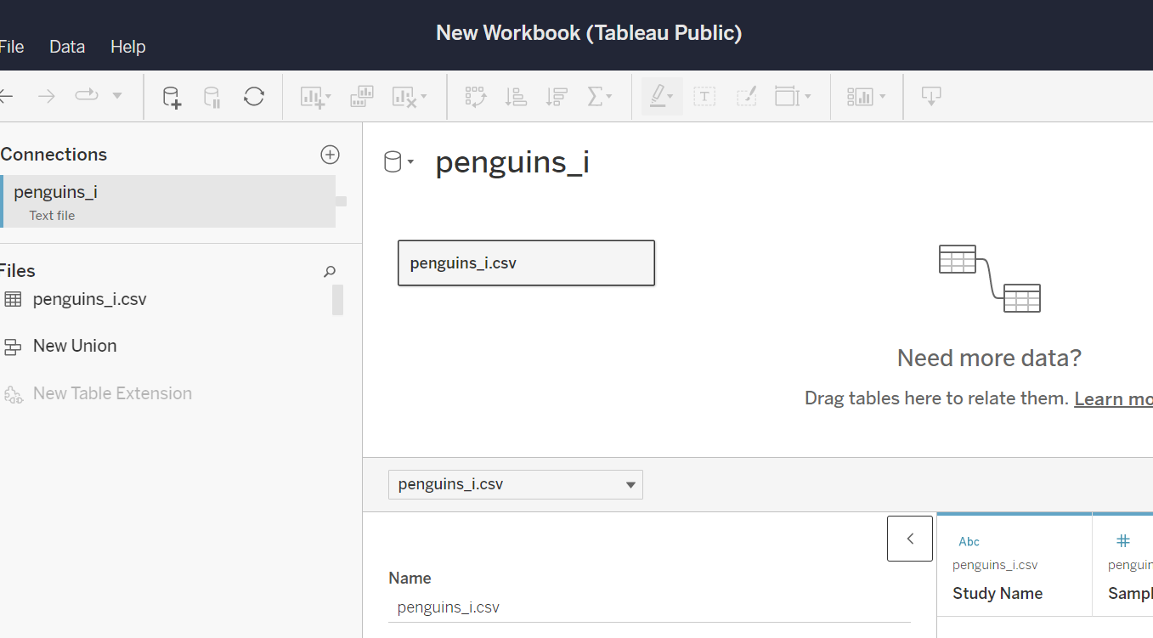
- On the very bottom, click “update now”
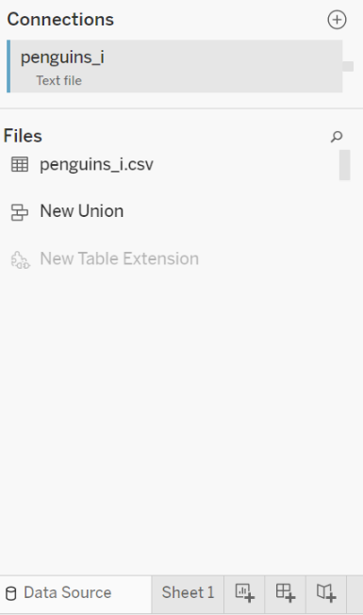
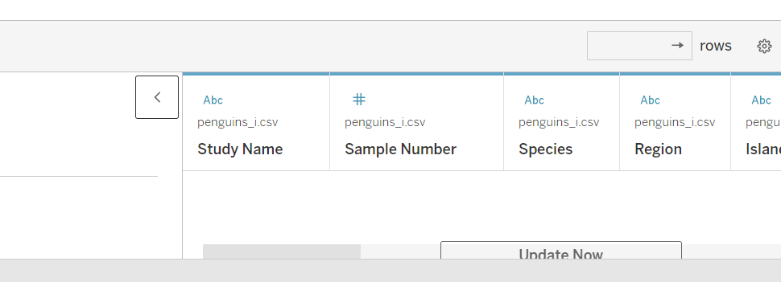
- Click on the “Sheet 1” tab at the very bottom left:
(or click control z on your keyboard)

- On the new page that comes up, you will see all the variables listed on the left:
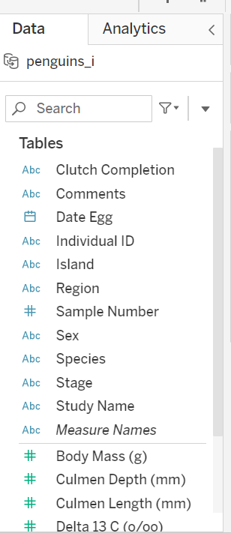

- Drag “Flipper length” onto the column shelf and “Species” onto the row shelf
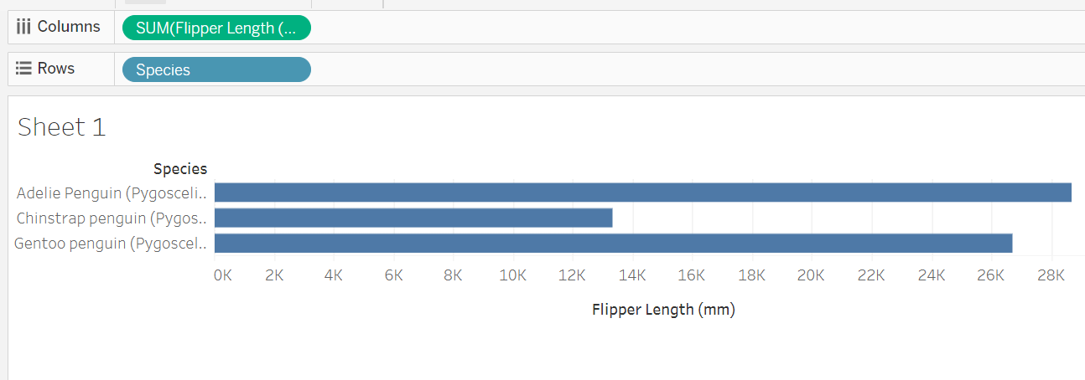

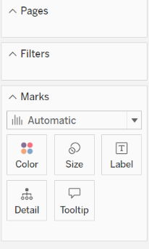
- On the “Marks”, slide “Sex” into Color:

- This is what your plot should look like now:
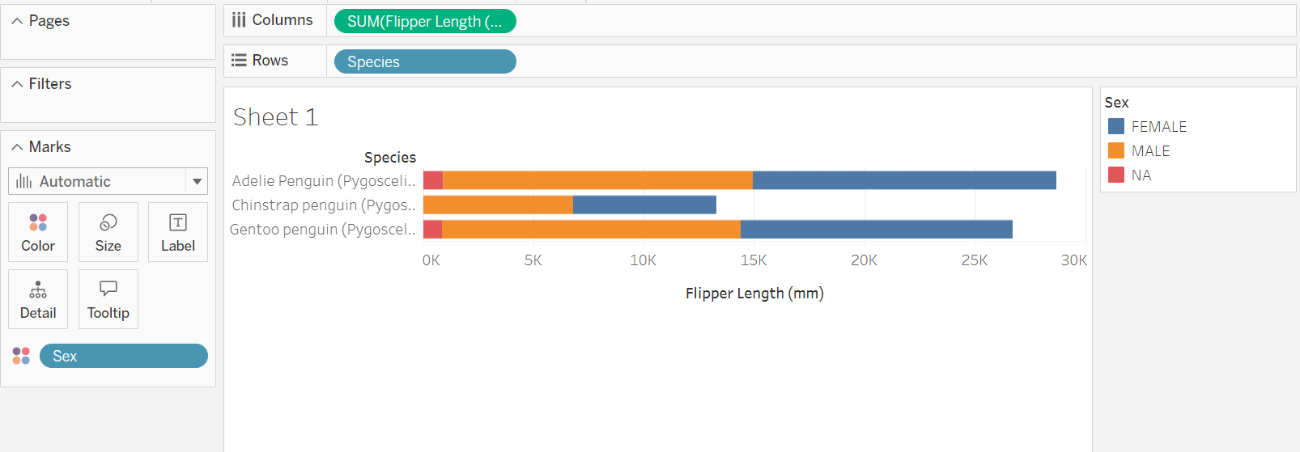
- Double click on “Sheet 1” above your plot and rename your plot: Penguin Flipper Length by Species and Sex
- This is what your screen should look like with the updated title.
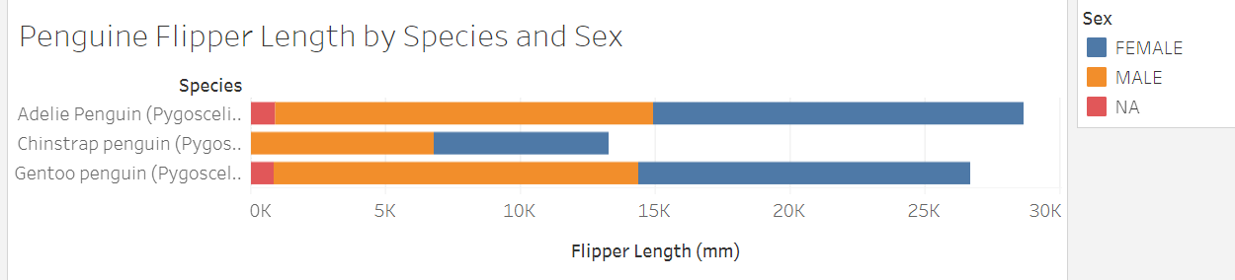
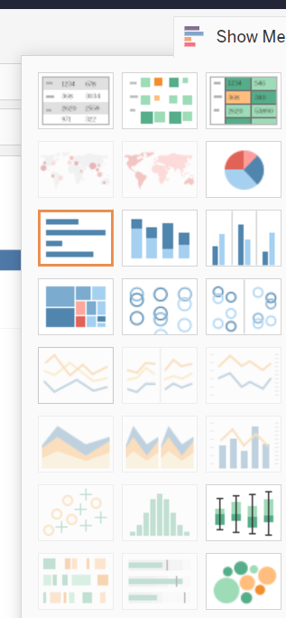
- Click on “Show Me” on the far top/right to see all data visualization options:

- On the bottom left, click “Sheet 2” to try making a new visualization using different variables and different types of plots from the different “Show Me” options.

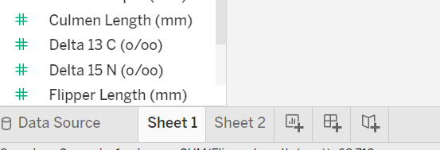
- Slide different types of variables onto the row and column shelves and see what kinds of new visualizations you can create.
- Once you are done creating your visualizations on one or more “Sheets”, click File Publish As, it will prompt to create an extract, it might take a while so be patient.
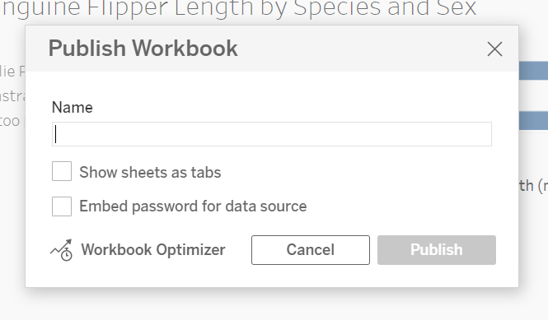

You can leave these two options unchecked.

- Name your file, anything you choose to name it, and click Publish.

Activity Questions:
- What is the average bill length by species and island?
- How does flipper length compare between male and female penguins for each species?
- What is the relationship between body mass and bill depth for each species?
- Which island has the highest average body mass for penguins?
- What is the count of each species on each island

Hypothesis: How might scientists use this kind of data visualization to make decisions about protecting penguin habitats?

Explore: What new variables did you make for your visualization on sheet 2? What did your plot show?

